For CYA1 I am applying to full time positions. In this document it contains each job I applied for.
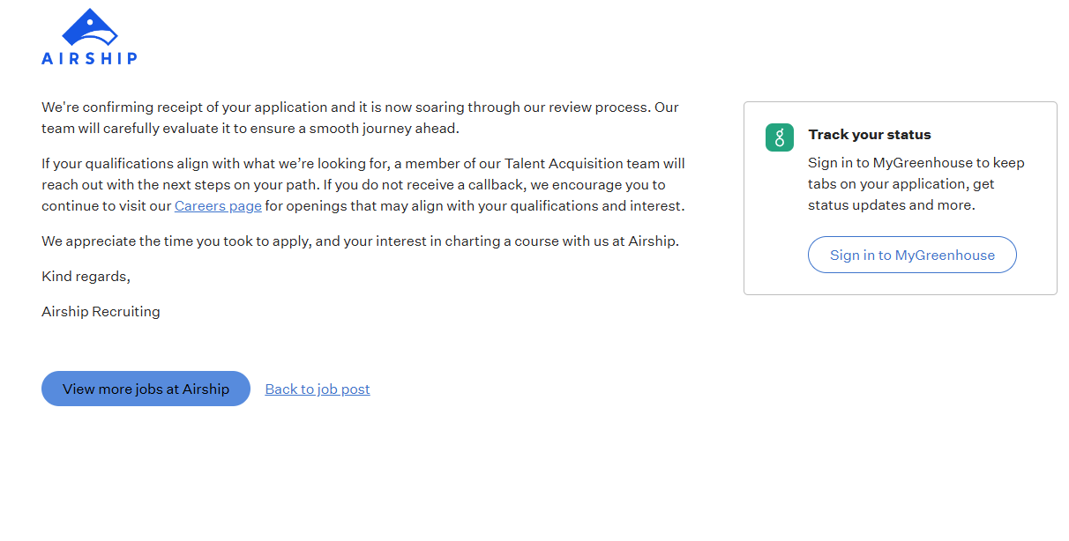
https://job-boards.eu.greenhouse.io/airship/jobs/4790894101/confirmation

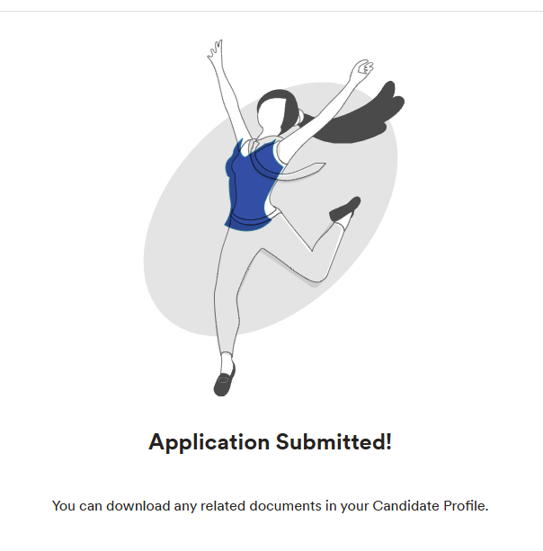
https://myjobs.adp.com/versovacareers/cx/my-applications

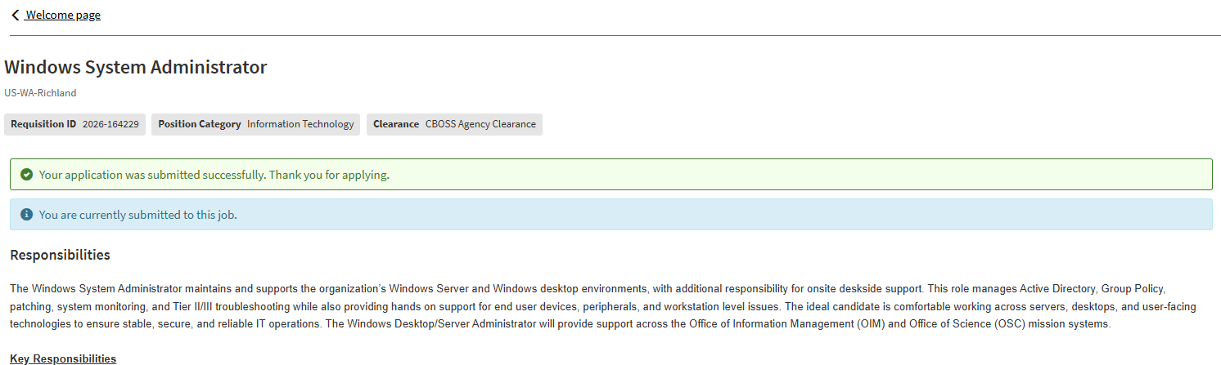
https://careers-peraton.icims.com/jobs/164229/windows-system-administrator/job?mode=submit_apply

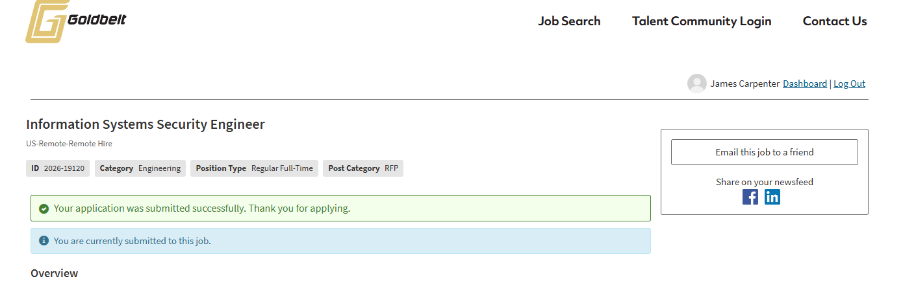
https://careers-goldbelt.icims.com/jobs/19120/information-systems-security-engineer/job?mode=submit_apply&from=assessment

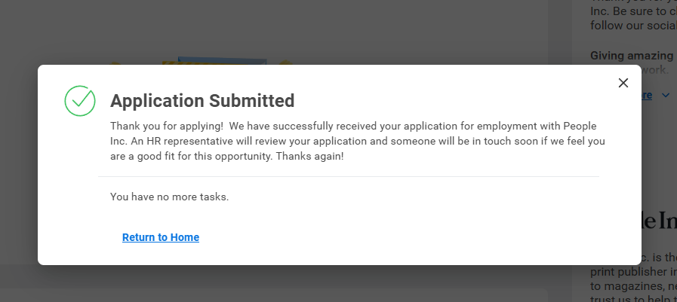
https://meredith.wd5.myworkdayjobs.com/en-US/EXT/userHome

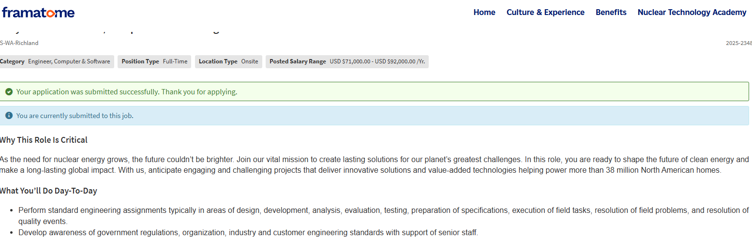
https://careers-framatome.icims.com/jobs/2348/early-career-software-computer-science-engineer/job?mode=submit_apply

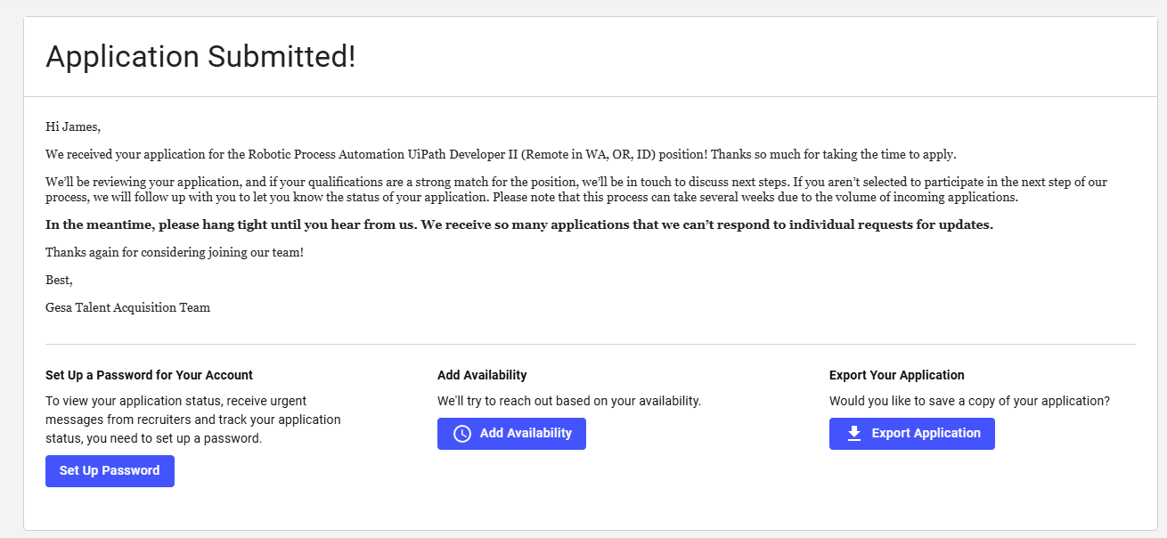
https://www.paycomonline.net/v4/ats/web.php/portal/E7A3819EACC22746FA78AB1D19A8ACB0/applications#/applications/1394727

